**Overview of the analysis**

The purpose of this analysis is to help Pewlett Haggard to determine the number of all employees eligible for the retirement package. Also, the company would like to identify employees who are eligible to participate in a mentorship program.

**Results**

Pewlett Haggard has 30.13% of people eligible to retire. The table displayed below shows the employees’ title that are most likely preparing for retirement.

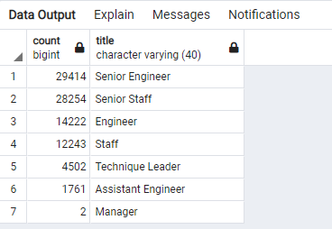

From the mentorship_elegible table we can see that there are only1549 total employees qualifying for mentorship/training.

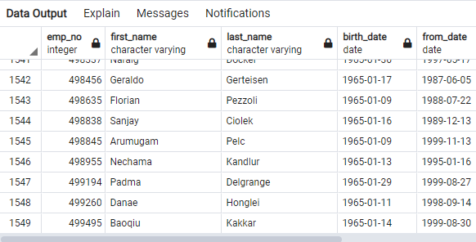

**Summary**

According to my analysis 30% of the company’s employees are preparing to retire. In other words, Pewlett Hackard will have to fill over 90,000 vacant positions. Considering that the company suffers from a low number of employees that are eligible for mentorship, this can lead to a personnel shortage once most eligible employees retire.